St Benedict’s College



**INFORMATION TECHNOLOGY**

**THEORY EXAMINATION**

GRADE 11

NOVEMBER 2012 MARKS: 120

TIME: 2 hours

**EXAMINER:** Ms Emmett

**MODERATOR:** Mrs Kench

LEARNER’S NAME: ________________________________ CLASS: ____

____________________________________________________________________

**INSTRUCTIONS**

1. Ensure that your name appears on all folio sheets.
2. Answer all the questions on the folio paper - labeling your answers clearly.
3. All descriptions are to be brief and concise.
4. Use the mark allocation for each question to guide your answer length.
5. Calculators may not be used.
6. Read each question carefully!

**Scenario**

As a Grade 11 pupil, you get told to sit with some Grade 9’s that are thinking of taking IT as a subject. These pupils were given some computer adverts and computer and technical magazines to read. Your job entails explaining any concept that they need help with.

Adverts:

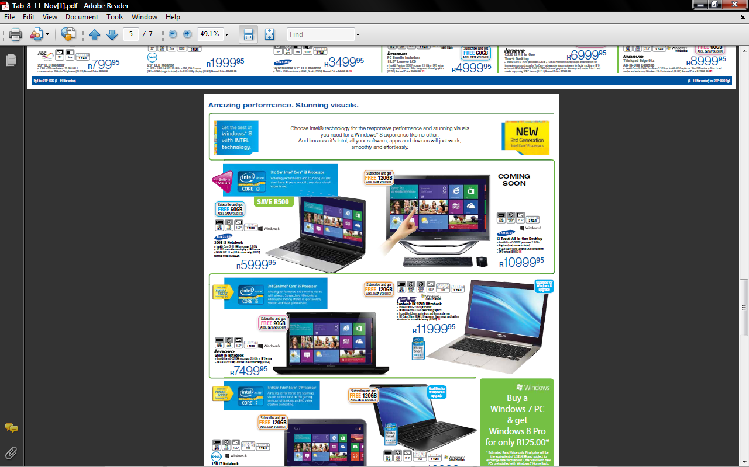**Samsung i3 Touch All-in-one Desktop**

* Intel Core i3 – 3220T processor 2.8 GHz
* 4 GB RAM
* 500 GB HDD
* 21.5” screen
* Windows 8
* Keyboard and mouse included
* WLAN 802.11 and Ethernet LAN connectivity
* DVD writer
* R10999.95
* 2 yr warranty

**Asus Zenbook UX32VD Ultrabook**

* Intel Core i5 – 3317U processor
* 4 GB RAM
* 500 GB HDD
* 24 GB SSD
* 1 GB nVidia GeForce GT620 dedicated graphics
* 13.3” HD Colour Shine SLIM LED screen
* Windows 7 Home Premium
* R11999.95
* 2 yr warranty

**Asus TF300G Tablet & Keyboard docking station**

* nVidia Tegra 3 Quad core 1.2GHz CPU
* 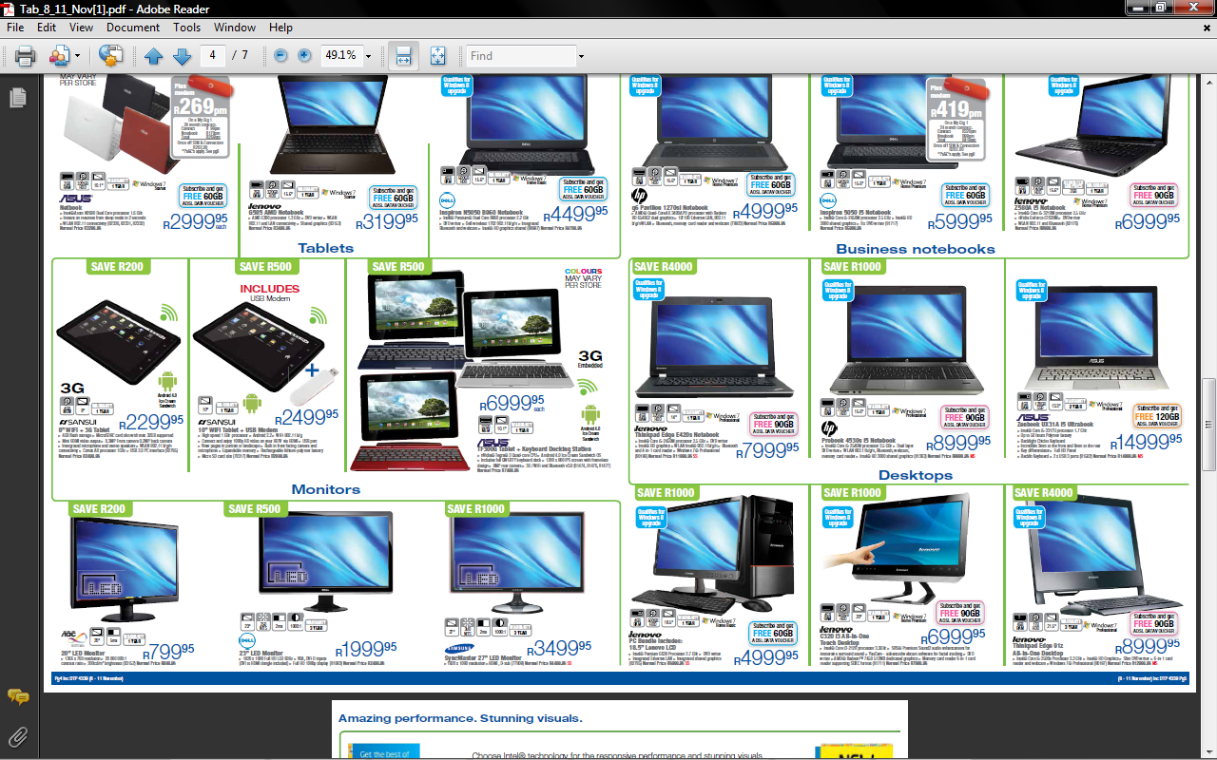1 GB RAM
* Up to 32 GB internal memory
* 10.1” 1280 x 800 IPS screen
* Includes full QWERTY keyboard dock
* 8 MP rear camera
* 3G / WiFi and Bluetooth v3.0
* Android 4.0 Ice Cream Sandwich OS
* R6999.95
* 1 yr warranty

**QUESTION 1**

***Terminology Quiz***

1.1 What do you understand by the following terms? ie define the terms

1. Instruction set.
2. RFID
3. Web 2.0
4. Checksum
5. Cloud computing
6. Podcast
7. Topology
8. Encryption
9. Dual channel memory
10. Software interrupt

**[20 marks]**

**QUESTION 2**

2.1 “A chipset refers to a group of integrated circuits that are designed to work together with a specific family of microprocessors, Because it controls communications between the processor and external devices, the chipset plays a crucial role in determining system performance.”

“Based on Intel Pentium-class microprocessors, the term *chipset* often refers to a specific pair of chips on the motherboard: the [northbridge](http://en.wikipedia.org/wiki/Northbridge_(computing)) and the [southbridge](http://en.wikipedia.org/wiki/Southbridge_(computing)).”

“In some newer Intel configurations (Core i7 and Core i5) , the northbridge and southbridge have been consolidated into a single IC, the "Platform Controller Hub" (PCH), effectively an enhanced southbridge.”

<http://en.wikipedia.org/wiki/Chipset>

1. Name 2 hardware components that are linked to the northbridge. (2)
2. Name 2 hardware components that are linked to the southbridge. (2)
3. Do all PCs, laptops and tablets have separate northbridge and southbridge chips? Justify your answer. (2)

2.2 Comparisons between the above adverts:

1. CPU’s
   1. Name the 2 different CPU manufacturers. (2)
   2. Clearly explain the term “quad core”. (1)
   3. The desktop and the laptop use Core i3 and i5. What is the difference between them? (1)
   4. What is the desktop processor speed? (1)
2. Memory & storage – the adverts mention four different forms of memory or storage.
   1. Name them and list the type of storage (eg magnetic, optical, etc) (4)
   2. Explain clearly how any two of the given types of storage work. (2)
   3. Why does the Ultrabook not have a DVD? (1)
3. Physical appearance
   1. There is no tower shown in the picture of the “All-in-One” desktop. Why not? (1)
4. Input & Output
   1. Do all 3 computers (in the adverts) have touch screens? (1)
   2. What is the main advantage of a touch screen? (1)
   3. Why would one need a tablet with a docking station? (1)
   4. Name 2 other input devices (other than keyboard/touch screen). (2)
5. General
   1. Why do you think the Ultrabook is more expensive that desktop? Give reasons for your answer. (2)
6. Connectivity
   1. Name one unbounded and one bounded type of connection technology in any of the three computers. (2)
   2. Explain clearly how any two of the network connection technologies work. (4)
7. OS
   1. Name the developers of two the various system software. (2)
   2. Why is Windows 7 or Windows 8 not used on the tablet? (2)
   3. If you had a Blackberry phone and a Windows dektop, which table would you buy? An Apple iPad or an Android based tablet such as Samsung? Assume both have similar capacity. Give two reason for your answer. (3)

2.3 Execution of instructions (stored in some form of memory) occurs in the CPU and the process is called the “machine cycle”.

1. Name the stages (in correct order) of the machine cycle. (4)
2. Which bus carries the instruction to the CPU? (1)
3. Which register stores the address of the next instruction to be fetched? (1)
4. Which bus carries the “read from“ or “write to” codes? (1)
5. Which register holds the results of a calculation? (1)

**[47 marks]**

**QUESTION 3**

3.1 One of the main functions of the OS is to control all hardware and software resources.

1. Name another 2 functions of the OS (2)
2. Process management is one of the resources that the OS must control. Give three tasks that the OS must ensure in order to manage the processes. (3)
3. Name another four types of processes that the OS needs to manage. (4)

3.2 In St Benedict’s College network:

1. What topology do we use? (1)
2. What access method do we use? (1)
3. What architecture do we use? (1)
4. What cabling is used in the computer centres (1)
5. What device is used to connect all the cables from one centre and also to connect to the server? (1)
6. How could each of the following be used to protect the student’s data:
   1. User names and passwords
   2. Firewall
   3. RAID
   4. UPS (8)

**[22 marks]**

**QUESTION 4**

4.1 Based on the adverts given in the scenario, choose one of the tablet / laptop / desktop and justify your decision using and 5 of the following headings. Make sure each heading is clearly labeled.

1. Portability
2. Work
3. Entertainment
4. Battery life
5. Security & malware issues
6. Applications
7. Speed
8. Social networking
9. Cost (5)

4.2 You need to explain to the Grade 9 students how the Internet has created the ‘Cut-and-Paste’ generation. Read the article below and then answer the questions that follow:

Technology is everywhere. ‘Net Geners’ cannot remember a time in their education where a computer was not used for some learning experience. Because of this ‘tech-savviness’ traditional educational practices and ethics are coming into question. Cheating, for example, always a major academic infraction, is on the rise on college campuses and technology is helping with cheating. Tlak to students and any one of them will tell you that cheating is prevalent and part of the culture, especially in technical disciplines. That is, if you use the strict definition of cheating.

Plagiarism is the academic infraction of choice. How can it not be though? Information ids easily available from the Internet, especially from sites like Wikipedia. Old term papers are being sold online. Because the Internet provides easy information fast, the temptation to click ‘copy/paste’ and pull in quotes from a website without attribution is great. But students still get caught because faculty members can search for familiar phrases or quotes to root out plagiarism.

Author: Ben McNeely is the managing editor of Technician, the student newspaper at North Carolina State University

<http://www.educause.edu/Resources>

1. Define the term “plagiarism”. (1)
2. Comment on what you think is meant by the ‘Cut-and-Paste’ culture mentioned in the above article. (2)
3. What is “Wikipedia”? (1)
4. If the article was reworded, and not referenced, would it be considered plagiarism? Motivate your answer. (2)
5. How could the authenticity and validity of the above Internet article be determined? (2)

4.3 E-commerce refers to commercial transactions that take place over the Internet, eg. On-line shopping or Internet banking. There are always security risks.

1. What does the ‘E’ in E-commerce refer to? (1)
2. ‘Phishing’ and ‘Pharming’ are two such commonplace risks today. Clearly explain each term. (4)
3. SSL is used only when accessing secure sites eg banking sites.
   1. What does the acronym SSL stand for? (2)
   2. How can you check if a site is secure? (2)
4. SSL makes use of ‘Public Key Encryption’ with a ‘Digital Certificate’. Define these terms. (2)

4.4 “Will Robots Ever Replace Humans?....

So you think you’re smarter than a robot? Robots will soon be used everywhere: manufacturing, mining, exploration, navigation, medical care, homecare, personal assistance and research…”

1. Discuss any 2 of the given areas above, clearly showing where and how robots are used effectively. (4)
2. Discuss the main question, clearly giving your justified opinion of the answer. (3)

**[31 marks]**